ABOUT NTPC:

**NTPC Limited**, formerly known as **National Thermal Power Corporation Limited**, is an Indian public sector undertaking. It is a statutory corporation incorporated under the [Companies Act 1956](https://en.wikipedia.org/wiki/Companies_Act_1956) and is under the [ownership](https://en.wikipedia.org/wiki/Ownership) of [Ministry of Power, Government of India](https://en.wikipedia.org/wiki/Ministry_of_Power_(India)). The headquarters of the company is situated at [New **Delhi**](https://en.wikipedia.org/wiki/New_Delhi). NTPC's core function is the generation and distribution of electricity to State Electricity Boards in India.  It is the largest power company in India with an electric power generating capacity of 67,907 MW. NTPC currently produces 25 billion units of electricity per month. NTPC currently operates 55 power stations (24 Coal, 7 combined cycle gas/liquid fuel, 2 Hydro, 1 Wind, and 11 solar projects). Further, it has 9 coal and 1 gas station, owned by joint ventures or subsidiaries.

It was founded by [Government of India](https://en.wikipedia.org/wiki/Government_of_India) in 1975, which now holds 51.1% of its equity shares (after divestment of its stake in 2004, 2010, 2013, 2014, 2016, & 2017)  
In May 2010, NTPC was conferred [Maharatna](https://en.wikipedia.org/wiki/Maharatna) status by the Union Government of India, one of only four companies to be awarded this status. It is ranked 400th in the [Forbes Global 2000](https://en.wikipedia.org/wiki/Forbes_Global_2000) for 2016.

Future Goals:

The company has developed a long-term plan to become a 128000 MW company by 2032. NTPC Limited is on an expansion spree to meet the power requirements of the country – it has targeted to add 14,058 MW in 12th Plan (from FY13 to FY 17) of which it had already added 4,170 MW in 2012–13, 1835 MW in 2013-14 1290 MW in 2014-15 and 1150 MW from April 2015 to 30 November 2015.  NTPC is diversifying its capacity mix with much emphasis on renewable energy. The company intends to add 10000 MW of Solar PV capacity in the next five years. NTPC also plans to go global. The public sector company has signed a memorandum of agreement with the Government of [Sri Lanka](https://en.wikipedia.org/wiki/Sri_Lanka) and [Ceylon Electricity Board](https://en.wikipedia.org/wiki/Ceylon_Electricity_Board) for setting up a 500 MW (2x250) coal-based thermal power plant in the island nation. An MoU has also been signed with Kyushu Electric Power Co. Inc., [Japan](https://en.wikipedia.org/wiki/Japan), for establishing an alliance for exchange of information and experts from different areas of the business.

ABOUT NTPC SIPAT:

**Sipat Super Thermal Power Station** is located at [Sipat](https://en.wikipedia.org/wiki/Sipat) in [**Bilaspur district**](https://en.wikipedia.org/wiki/Bilaspur_district,_Chhattisgarh)**in state of**[**Chhattisgarh**](https://en.wikipedia.org/wiki/Chhattisgarh)**. The power plant is one of the**[**coal**](https://en.wikipedia.org/wiki/Coal)**based** power plants of [NTPC](https://en.wikipedia.org/wiki/National_Thermal_Power_Corporation). The coal for the power plant is sourced from Dipika Mines of [South Eastern Coalfields Limited](https://en.wikipedia.org/wiki/South_Eastern_Coalfields_Limited)

The project has an installed capacity of 2980 MW consisting of two stages, stage one which got commissioned late was of 3 units of 660 MW each involving super-critical boilers technology and stage two consisted of 2 units of 500 MW each. PM Manmohan Singh inaugurated the Sipat Thermal Power Plant on September 20, 2013.

|  |  |  |  |  |
| --- | --- | --- | --- | --- |
| stage | **Unit number** | Installed capacity (MW) | Date of commissioning | status |
| 1st | 1 | 660 | 2011 June | Running |
| 1st | 2 | 660 | 2011 December | Running |
| 1st | 3 | 660 | 2012 June | Running |
| 2nd | 4 | 500 | 2007 may | Running |
| 2nd | 5 | 500 | 2008 august | Running |
| Total | five | 2980 |  |  |

*Mission* **PROVIDE RELIABLE POWER AND RELATED SOLUTIONS IN AN ECONOMICAL, EFFICIENT AND ENVIRONMENT FRIENDLY MANNER, DRIVEN BY INNOVATION AND AGILITY.**

*Vision* **TO BE THE WORLD’S LEADING POWER COMPANY, ENERGIZING INDIA’S GROWTH**.

INTRODUCTION OF IOT:

***IoT is network of interconnected computing devices which are embedded in everyday objects, enabling them to send and receive data.***

In the upcoming years, IoT-based technology will offer advanced levels of services and practically change the way people lead their daily lives.

**Main components used in IoT:**

***. Low-power embedded systems*:** Less battery consumption, high performance are the inverse factors that play a significant role during the design of electronic systems.

**. *Sensors*:**Sensors are the major part of any IoT applications. It is a physical device that measures and detect certain physical quantity and convert it into   signal which can be provide as an input to processing or control unit for analysis purpose.

**. *Control Units*:**  It is responsible for major processing work of IoT devices and all logical operations are carried out here.

**. *Cloud computing:***  The data is processed and learned, giving more room for us to discover where things like electrical faults/errors are within the system.

**. *Networking connection:***In order to communicate, internet connectivity is a must where each physical object is represented by an IP address.

***Desired Quality of any IoT Application:***

***. Interconnectivity:*** *It is the basic first requirement in any IoT infrastructure.*

***.******Heterogeneity:*** *There can be diversity in IoT enabled devices like different hardware and software but they should connect and interact with each other despite of so much heterogeneity.*

***. Dynamic in nature:*** *IoT devices should dynamically adapt themselves to the changing surroundings like different situation and different prefaces.*

***. Self-adapting and self-configuring technology:*** *it should be flexible to work in different weather conditions and different light situations (morning, afternoon, or night).*

***. Intelligence:*** *Just data collection is not enough in IoT, extraction of knowledge from the generated data is very important.*

***. Scalability& Identity:*** *An IoT setup should be capable of handling the expansion. Each IoT device has a unique identity (e.g., an IP address).*

**Application Domains:** IoT is currently found in four different popular domains:

1) Manufacturing/Industrial business - 40.2%

2) Healthcare - 30.3%

3) Security - 7.7%

4) Retail - 8.3%

**Modern Applications:**

1. Smart Grids and energy saving
2. Smart cities
3. Smart homes/Home automation
4. Healthcare
5. Earthquake detection
6. Radiation detection/hazardous gas detection
7. Smartphone detection
8. Water flow monitoring
9. Traffic monitoring
10. Wearables
11. Smart door lock protection system
12. Robots and Drones
13. Healthcare and Hospitals, Telemedicine applications
14. Security
15. Biochip Transponders (For animals in farms)
16. Heart monitoring implants (Example Pacemaker, ECG real time tracking)

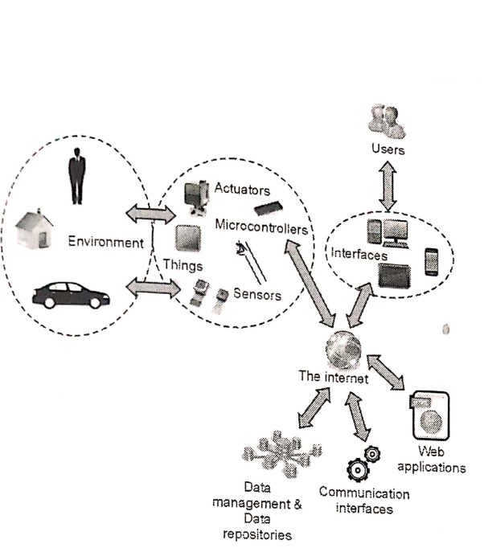

***WORK OF IOT***